

GL BAJAJ INSTITUTE OF TECHNOLOGY AND MANAGEMENT, GREATER NOIDA
RESEARCH REPORT ON
“SCOPE OF HYBRID CARS IN CURRENT ERA”
OF
TOWARDS THE PARTIAL FULLFILLMENT FOR THE AWARD OF DEGREE OF
MASTERS OF BUSINESS ADMINISTRATION (BA)

(Dr. A.P.J. Abdul Kalam Technical University, Lucknow, Uttar Pradesh)

By
DISHANT SHARMA
SEC-I
(Admission No.-24162CN051)
Session 2024-25

Under the Supervision of

DR. SHAIVYA DIXIT

A Research study on Scope of Hybrid Cars in Current Era

Origin of the Idea/ Literature review
The concept of hybrid cars originated from the growing concerns over fossil fuel depletion, rising carbon emissions, and environmental degradation. The conventional internal combustion engine (ICE)-powered vehicles have long dominated the transportation sector, contributing significantly to greenhouse gas emissions and global climate change. The demand for sustainable energy solutions, combined with the advancements in battery technology and electric propulsion, led to the development of hybrid vehicles. By merging traditional fuel-driven systems with electric motors, hybrid cars emerged as a promising alternative to mitigate environmental damage while ensuring efficiency and practicality for consumers. Early prototypes of hybrid technologies date back to the late 19th century, but the real momentum occurred in the late 20th century with the introduction of commercially viable hybrid models like the Toyota Prius. Today, hybrid cars continue to evolve as a stepping stone toward fully electric mobility.
The idea of hybrid cars dates back to the early 20th century when engineers explored ways to improve fuel efficiency and reduce emissions. One of the earliest hybrid vehicles was the Lohner-Porsche Electromobility, designed by Ferdinand Porsche in 1900, which combined an electric motor with an internal combustion engine.
Belgian engineer Henri Pieper also contributed to hybrid technology by developing a small petrol-electric vehicle in the late 19th century. However, hybrid cars struggled to gain traction throughout the 20th century due to the dominance of gasoline-powered vehicles and the relatively low cost of fuel.
The modern resurgence of hybrid cars began in the late 1990s with the introduction of the Toyota Prius in 1997, which became the first mass-produced hybrid vehicle. This marked a turning point, as rising environmental concerns and fuel prices encouraged automakers to invest in hybrid technology.

Introduction of the Idea
Hybrid cars operate on a dual propulsion mechanism that combines an internal combustion engine with an electric motor. This integration allows for better fuel efficiency, reduced carbon emissions, and an optimized driving experience. Unlike fully electric vehicles (EVs), hybrids do not rely solely on external charging stations, making them more accessible and convenient in regions where EV infrastructure is still developing. Hybrid vehicles use regenerative braking, which captures and stores kinetic energy, further enhancing efficiency. With their ability to switch between power sources, hybrid vehicles are designed to address the limitations of traditional gasoline-powered cars and the infrastructural challenges of EVs. The automotive industry sees hybrid technology as an essential transition toward sustainable mobility, providing an effective solution to environmental concerns without compromising consumer accessibility.

Objectives of the Study
The primary objective of this research is to evaluate the scope of hybrid cars in the current era, focusing on their technological advancements, market growth, environmental impact, and consumer adoption trends. Specific objectives include:
- Examining the historical development and technological evolution of hybrid vehicles.
- Analysing consumer behaviour and acceptance of hybrid cars compared to fully electric and conventional vehicles.
- Evaluating the economic benefits, including cost-effectiveness and fuel savings, associated with hybrid vehicles.
- Assessing government policies, incentives, and regulations supporting hybrid vehicle adoption.
- Exploring future trends in the automotive industry and the transition toward electric mobility.

Need of the Study
The necessity of this research stems from the growing urgency to adopt sustainable alternatives in the transportation sector. Traditional ICE vehicles (internal combustion engine) remain a significant contributor to air pollution and climate change, demanding innovative solutions that bridge the gap between fuel efficiency and environmental responsibility. While fully electric vehicles are often seen as the ideal alternative, infrastructural and economic limitations hinder their widespread adoption. Hybrid vehicles address these challenges by combining electric propulsion with conventional engines, ensuring accessibility and reduced emissions without requiring extensive infrastructure upgrades. Understanding the scope of hybrid cars in the present era is critical for formulating policies, encouraging technological advancements, and driving sustainable automotive development.
Conceptual Framework
The study is structured on a multidimensional conceptual framework encompassing:
- Technological Perspective – Understanding hybrid vehicle propulsion systems, energy management, and fuel efficiency.
- Economic Viability – Evaluating cost savings, fuel efficiency, maintenance, and long-term sustainability.
- Environmental Impact – Measuring reductions in greenhouse gas emissions and resource consumption.
- Market Adaptation – Analysing consumer adoption trends, purchase incentives, and barriers to acceptance.
- Policy Influence – Assessing governmental interventions and industrial regulations supporting hybrid technology. By integrating these dimensions, the study provides a comprehensive perspective on hybrid vehicles' role in modern transportation.
Feasibility of the Idea
Hybrid cars have proven to be technologically feasible, with advancements in battery technology, regenerative braking, and smart energy management systems. Major automobile manufacturers have successfully integrated hybrid technology into mainstream production, proving its practicality in real-world applications. Government incentives, including tax reductions and purchase subsidies, further enhance the feasibility of hybrid adoption. While challenges such as higher initial costs and battery lifecycle limitations exist, continuous research and innovation aim to address these concerns. The feasibility of hybrid vehicles extends beyond environmental benefits, offering a realistic solution to fuel dependency and economic sustainability.

Blueprint to Implement the Idea
Implementing the widespread adoption of hybrid cars requires a structured approach, including:
- Policy Support – Governments must introduce tax benefits, subsidies, and regulations promoting hybrid technology.
- Infrastructure Development – Expanding battery production facilities, improving fuel efficiency standards, and enhancing charging networks.
- Consumer Awareness Programs – Educating consumers on the environmental and financial advantages of hybrid cars.
- Industry Collaboration – Automotive manufacturers should invest in hybrid technology research and competitive pricing strategies.
- Technological Innovation – Advancing battery efficiency, hybrid engine optimization, and smart energy management systems. By following these strategies, hybrid vehicles can become a mainstream component of sustainable transportation.

Implications of the Study
The findings of this research highlight the transformative potential of hybrid vehicles in shaping the automotive industry's future. The implications include:
- Environmental Sustainability – Hybrid cars contribute significantly to reducing emissions and mitigating climate change.
- Economic Benefits – Consumers experience lower fuel costs and improved vehicle longevity.
- Policy Influence – Governments can use research findings to create more effective green mobility incentives.
- Technological Advancements – Innovations in hybrid technology pave the way for fully electric vehicle evolution. Understanding these implications allows stakeholders to make informed decisions that promote sustainable automotive solutions.

Research Methodology
The research methodology is the framework through which this study investigates the scope of super hybrid cars in current era. This part highlights the research design, data collection methods, sampling technique, data analysis tools and limitations. It is structured to ensure the study is both systematic and replicable providing valid and reliable insights into addressing scope of super hybrid cars in current era.
1. Research Design
- Descriptive Research: Provides an overview of hybrid car adoption, market trends, and technological developments. It also focuses on understanding their market potential, technological advancements, environmental impact, and consumer adoption trends.
- Comparative Analysis:
Feature | Super Hybrid Cars | Present Hybrid Brands
Technology | AI-driven energy management, lightweight materials | Traditional hybrid-electric systems
Fuel Efficiency | Ultra-low fuel consumption | Good fuel economy but not as optimized
Pricing | Higher due to advanced technology | More affordable for consumers
Environmental Impact | Ultra-low emissions, optimized fuel use | Eco-friendly but not as efficient as super hybrids

2. Data Collection Methods
- Primary Data: Surveys, interviews with industry experts, and consumer feedback for car usage patterns in different regions.
- Secondary Data: Government reports, automotive industry publications, and academic research papers.

3. Sampling Design
- Target Population: Consumers, automobile manufacturers, policymakers, and environmental experts.
- Simple Random Sampling Technique: Every individual in the population has an equal chance of being selected.
- Sample size: Minimum 50 respondents, ensuring diversity in demographics.
- Target demographics:
- Genger: All
- Location: Nearby urban & rural locality
- Age: 25-50
- Economic class: Top & Middle

4. Data Analysis Methods
- Quantitative Analysis/ Descriptive Statistics: Statistical tools to measure adoption rates, cost-effectiveness, and fuel efficiency e.g.
- Measures of Central Tendency: Mean, median, and mode to determine the average purchase price or preferred car models.
- Measures of Dispersion: Range, variance, and standard deviation to analyse price variations and consumer preferences.
- Graphical Representations: Histograms, pie charts, and bar graphs to visualize purchase trends across different demographics.
Inferential Statistics
Inferential statistics help draw conclusions about a larger population based on sample data. Key methods include:
- Hypothesis Testing: Determining whether factors like price, fuel efficiency, or government incentives significantly impact purchase decisions.
- Regression Analysis: Identifying relationships between variables, such as income levels and hybrid car adoption rates.
- Confidence Intervals: Estimating the range within which the true population parameters (e.g., average purchase price) lie.
- Qualitative Analysis: Case studies on successful hybrid car models and policy impacts.
Toyota Prius:
The Prius is widely recognized as a pioneer in the hybrid car market, being the first mass-produced hybrid. Its success, particularly with celebrities, helped raise awareness and acceptance of hybrid technology.
Chevy Volt:
GM's Volt, introduced in 2010, was a significant step in the development of plug-in hybrid technology, aiming for a substantial all-electric range while also incorporating a gasoline engine for extended travel.
Nissan Note e-power:
This Japanese model showcases a series hybrid system, where the electric motor directly drives the wheels, and the gasoline engine powers the electric motor generator.

5. Validity & Reliability
- Ensuring data accuracy through cross-verification with multiple sources.
- Using standardized research tools for consistency.
6. Research Approach
The study uses a mixed method approach:
- Primary Data: Collected through surveys/ questionnaires administered to automobile/ car users.
- Secondary Data: Gathered from academic journals, industry reports, case studies, and existing literature.
7. Scope of the study
The study is geographically limited to India, with a special focus on urban and semi-urban consumers. The results may not be fully generalizable to all segments but they provide crucial understandings for emerging technologies and innovations with similar appearances.
8. Ethical Consideration
- Participation was voluntary
- Respondent’s identities were kept confidential
- No sensitive personal information was collected
- Informed consent was taken before survey distribution
Research methodologies used
- Survey & Questionnaires – Gathering public opinion, consumer preferences, and awareness levels of the consumers across different age groups, professions and locations in Delhi NCR through google forms.
- Case Studies – Examining successful hybrid car markets in different countries to understand adoption trends and challenges.
Toyota Prius:
The Prius is widely recognized as a pioneer in the hybrid car market, being the first mass-produced hybrid. Its success, particularly with celebrities, helped raise awareness and acceptance of hybrid technology.
Chevy Volt:
GM's Volt, introduced in 2010, was a significant step in the development of plug-in hybrid technology, aiming for a substantial all-electric range while also incorporating a gasoline engine for extended travel.
Nissan Note e-power:
This Japanese model showcases a series hybrid system, where the electric motor directly drives the wheels, and the gasoline engine powers the electric motor generator.

- Market Analysis – Analysing sales data, pricing trends, and market demand for hybrid vehicles.
- Comparative Analysis – Comparing super hybrid cars with traditional and fully electric vehicles in terms of cost-effectiveness, efficiency, and sustainability.
- Policy & Regulation Analysis – Investigating government policies, incentives, and subsidies supporting hybrid car adoption.
- Literature Review – Analysing existing studies, industry reports, and academic papers on hybrid vehicles, market trends, environmental impact, and technological advancements.

ANALYSIS
I have done the analysis using python codes On JUPYTER notebook.
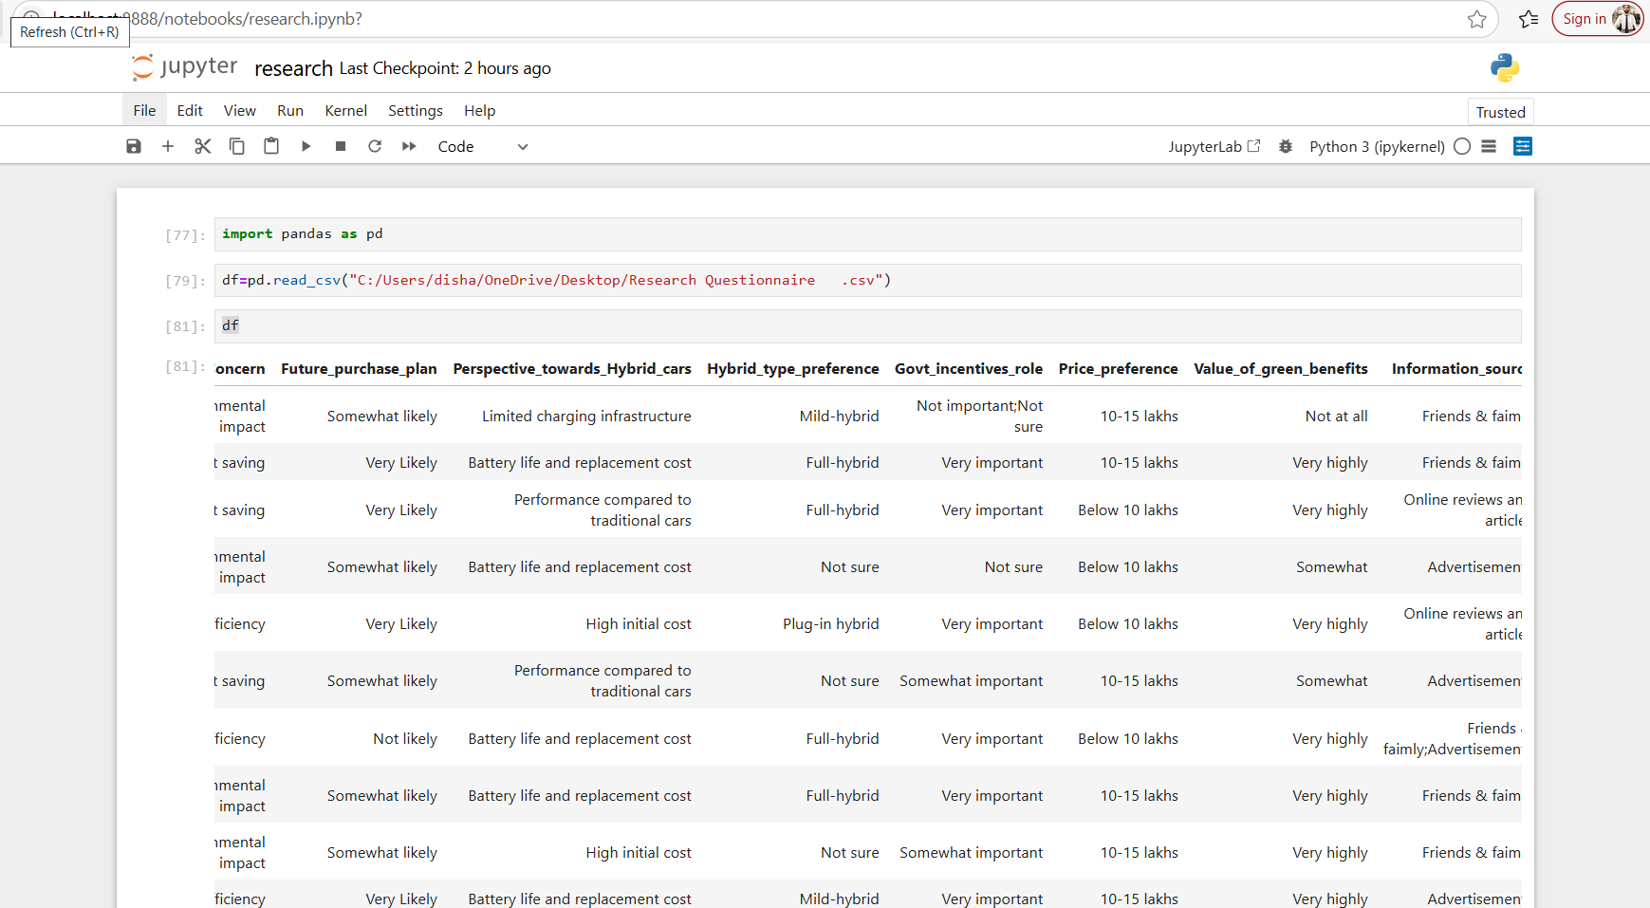


- What is the most important factor for you when considering a hybrid car?

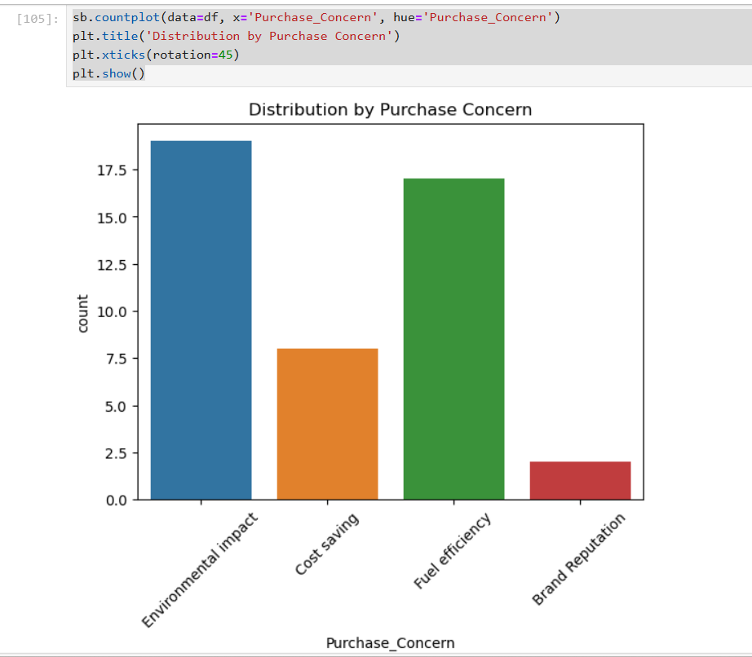

Most Preferred Price Range:
- "10–15 lakhs" is the most preferred price range, with nearly 24 respondents.
- This suggests it's the sweet spot for affordability and value among the surveyed group.
Second Preference:
- "Below 10 lakhs" comes next with around 11 respondents, indicating a considerable interest in budget-friendly options.
Mid-Range Interest:
- "15–20 lakhs" has moderate interest with 6 respondents.
- "Above 20 lakhs" drops further, suggesting fewer people are willing to spend that much.
Least Selected Option:
- The category "10-15 lakhs; 15-20 lakhs" has very low count

- How likely are you to purchase a hybrid car in the next 5 years?



Most Respondents – "Very Likely":
- "Very Likely" has the highest count — around 24 respondents.
- This shows strong future demand and positive consumer interest.
Second Highest – "Somewhat Likely":
- Around 18 respondents chose "Somewhat likely", reinforcing that many are at least considering a future purchase.
Very Few – "Not likely", "Not sure":
- Both have minimal responses (2–3 each), suggesting low levels of disinterest or uncertainty.
Anomaly – Duplicate/Confused Category:
- The last bar labelled "Very Likely; Somewhat likely" is unusual.
- This may indicate data entry inconsistency, where a respondent selected multiple options or the field wasn't cleaned.

- What type of hybrid car would you prefer?
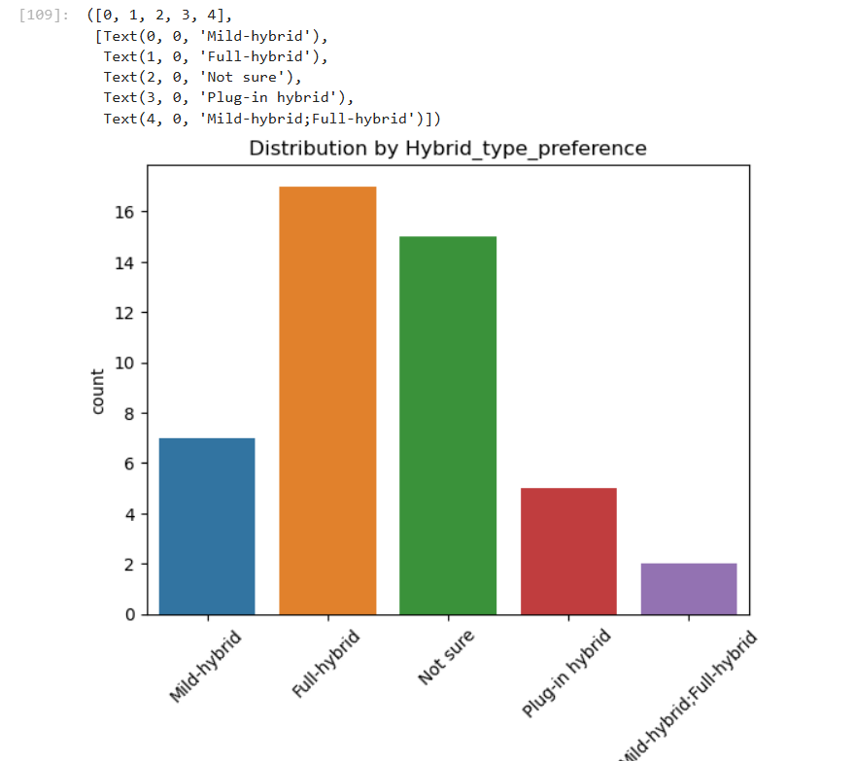
Most Preferred – Full Hybrid:
- Full-hybrid is the most preferred type, with 17 respondents.
- This indicates a strong lean toward vehicles that can run solely on electric power at times, not just assist the engine.
High Uncertainty – "Not sure":
- 15 respondents are uncertain about their preference.
- This suggests a significant portion of the audience may lack technical knowledge or need more education/awareness.
Mild Hybrid:
- Chosen by 7 respondents, indicating moderate preference for simpler hybrid systems that only support the engine.
Plug-in Hybrid:
- Only 5 respondents prefer plug-in hybrids, likely due to:
  - Limited charging infrastructure
  - Higher upfront cost
  - Lack of understanding
Ambiguous Entry – "Mild-hybrid; Full-hybrid":
- 2 respondents selected both types, possibly due to:
  - Confusion in survey options
  - Genuine indecision

- How important is government incentives (e.g., tax benefits) in your decision to buy a hybrid car?
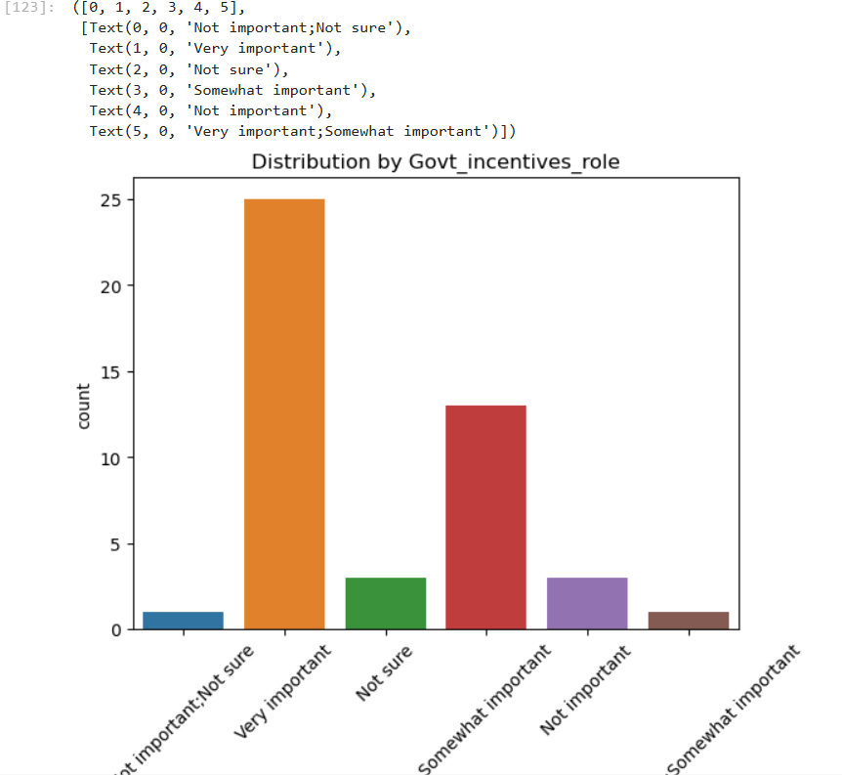

Majority View – "Very Important":
- 25 respondents marked government incentives as "Very important".
- This suggests a strong dependency on financial support from the government to influence purchase decisions.
Second Highest – "Somewhat Important":
- About 13 respondents view incentives as "Somewhat important".
- They value it but may still consider purchasing without incentives.
Low Indifference or Rejection:
- Very few selected "Not important" or "Somewhat important" again (possible duplicate category due to data entry).
Uncertainty – "Not sure":
- A small portion (around 3 respondents) are undecided about the importance of incentives.

- What is your preferred price range for a hybrid car?
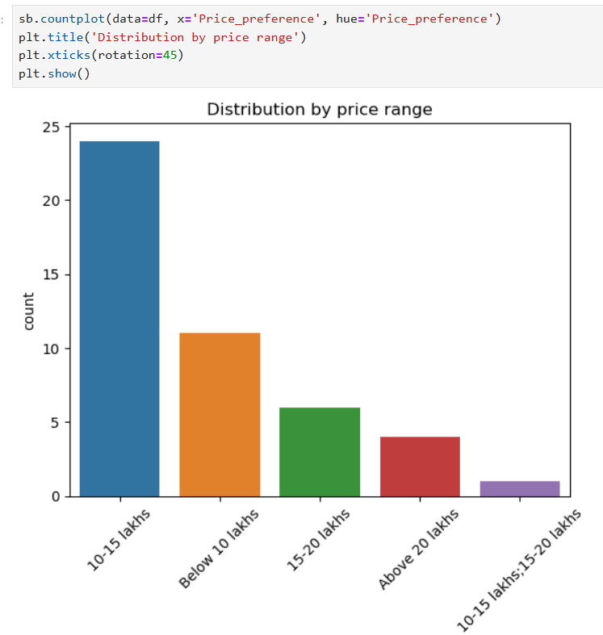
Top Preference – ₹10–15 lakhs:
- Most respondents (24) prefer the ₹10–15 lakhs range.
- This suggests that vehicles in this segment are perceived as offering the best value for money.
Next Popular – Below ₹10 lakhs:
- 11 respondents prefer vehicles priced below ₹10 lakhs.
- These buyers are likely price-sensitive, looking for affordability.
Moderate Interest – ₹15–20 lakhs:
- 6 respondents chose this bracket, showing limited but present interest in mid-premium options.
Low Preference – Above ₹20 lakhs:
- Only 4 respondents are comfortable spending more than ₹20 lakhs.
- Indicates that luxury or high-end vehicles are not a major draw for the majority.
Data Entry Issue – "10-15 lakhs;15-20 lakhs":
- This category appears to represent overlapping choices or multiple selections.
- Only 1 respondent falls in this ambiguous category.

- How much do you value the environmental benefits of hybrid cars?


Overwhelming Majority – "Very highly":
- Around 35 respondents rate green benefits as "Very highly" important.
- This indicates strong environmental consciousness among the audience.
Moderate Segment – "Somewhat":
- A smaller group values green benefits to some extent.
- They may recognize the benefits but aren’t primarily driven by them.
Minimal Concern – "Not much" and "Not at all":
- Very few respondents (2–3 total) placed little to no importance on green benefits.
- These may be cost- or performance-focused consumers.

- What is your primary source of information about hybrid cars?
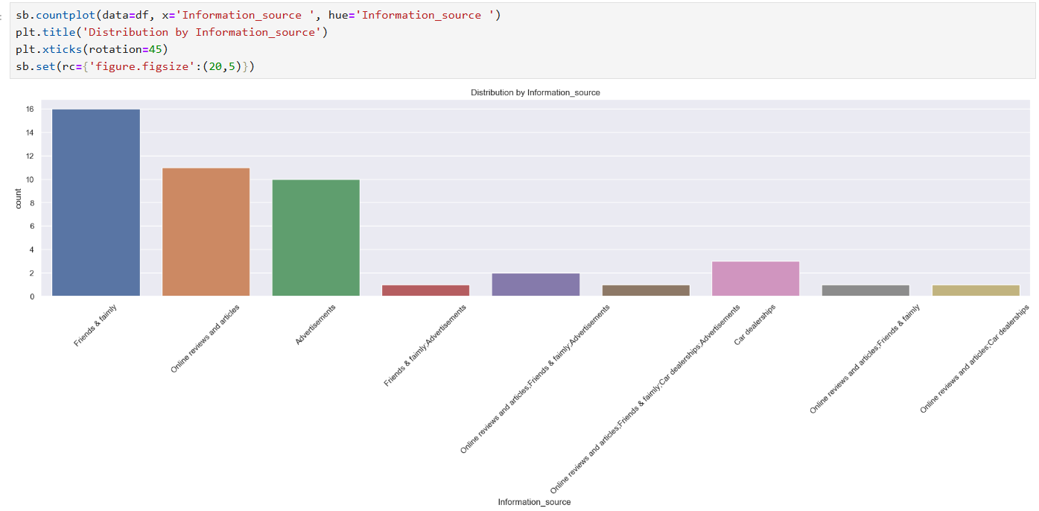Top Influencer – "Friends & family":
- The most cited source, with 16 responses.
- Word-of-mouth and personal trust play a crucial role in influencing purchase decisions.
Second & third – "Online reviews and articles" & "Advertisements":
- Around 11 and 10 respondents, respectively, rely on these.
- This indicates growing trust in digital media and the continued influence of advertising.
"Car dealerships" (Standalone):
- Only around 3 people consider dealerships as their primary source.
- This may reflect lower trust or limited access to firsthand dealership information.
Mixed Sources (Combined answers):
- Options like "Friends & family + Advertisements", "Online reviews + Friends & family", etc., have much lower counts (1–2 each).
- These reflect a smaller group of multi-source decision makers.

Conclusion

The research study on the scope of hybrid cars in the current era has revealed promising insights into the potential of hybrid vehicles to transform the automotive industry. With the growing concern over environmental sustainability and the need to reduce greenhouse gas emissions, hybrid cars have emerged as a viable solution.
The study highlights the benefits of hybrid cars, including improved fuel efficiency, reduced emissions, and lower operating costs. Furthermore, advancements in technology have made hybrid vehicles more affordable and accessible to a wider audience.
However, the study also identifies challenges that need to be addressed, such as the high upfront cost of hybrid vehicles, limited charging infrastructure, and consumer awareness.
In conclusion, hybrid cars have a significant scope in the current era, offering a cleaner and more efficient alternative to traditional gasoline-powered vehicles. As governments and companies invest in sustainable technologies, the demand for hybrid vehicles is expected to rise, driving innovation and growth in the industry. With continued research and development, hybrid cars can play a crucial role in shaping a more environmentally friendly transportation system.

